



**Dear Sir/Ma’am,**

Thank you for connecting with TripzyGO International!

We are happy and grateful to have this opportunity to plan your holidays. Planning someone's holidays is a huge responsibility and it is important to deliver great experiences. We do that by following one simple motto - You, the customer comes first. With us, you will always have fun loving holiday experiences because that is our utmost priority.

Promising a memorable trip to you on your holidays!

### Travel Details:

### Destination:

### Bali

### Date of Travel:

13 Aug, 2023

### Number of Travelers:

04 Adults

### Tour Duration:

### 09 Nights/ 10 Days

**Accommodation Details:**

|  |  |  |
| --- | --- | --- |
| Destination | Hotel | No of Nights |
| Kuta | Bliss Surfer Kuta | 05 |
| Gili trawangan | Aston Sunset Beach Resort Gili | 01 |
| Seminyak | Maison at C Boutique Hotel & Spa Seminyak | 03 |

**Total package price - INR 1,74, 230/- For 04 Adults Without flight**

**Day Wise Itinerary of the trip:**

**Day 1: Bali: Arrival and leisure**

On your arrival the international airport of Bali, one of our tour coordinator will receive you at the international flight arrival terminal. You will be escorted to Bali Denpasar on a private cab. On your way to the hotel, your tour representative will hand over to you all the documents, tour guides, local maps etc. As you have arrived at the hotel, check in and explore all the amenities on the hotel. Relax and settle yourself. In the evening, go out and explore the neighborhood. The rest of the day is for you to relax with your family members. Have a delightful dinner at the resort and doze your day off.

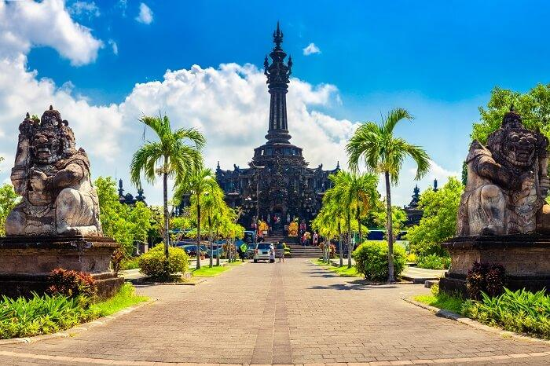

**Day 2 Water Sports (Banana Boat, Adventure / Couple Parasailing, Jet Ski + Glass Bottom Boat + Turtle Island) + Padang Padang beach + Dreamland Beach**

depending on your hotel location. We will take you to Tanjung Beanoa area for water sports. We have included Banana Boat ride, Adventure / couple parasailing & Jet Ski, (One ride each), in the package cost already. Other water sports can be done at your own expenses, with direct payment to the water sports company. Later continue to Padang Padang Beach followed by Dreamland beach, both known for there hidden beauty and beautiful sunset points

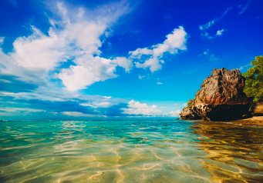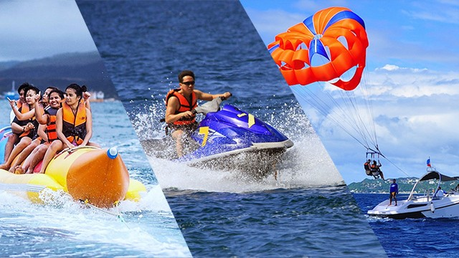

## Day 03 Full Nusa Penida West tour (PRIVATE) - 4 beaches - Kelingking Beach, Angel Bilabong, Broken Bay, Crystal,bay + Complimentary Snorkelling (If time permits

Embark on a Nusa Penida day trip from Bali and enjoy a full day of adventure and breath taking views Make a stop at Kelingking Beach and have your photo taken with the famed T-Rex-shaped cliffs as your backdropGet a chance to swim in the crystal clear emerald waters of the island's natural infinity pool, Angel BillabongExperience the diverse marine life of Bali (depends on the weather) during snorkeling activities at Crystal Bay, Manta Bay, or Gamat Ba

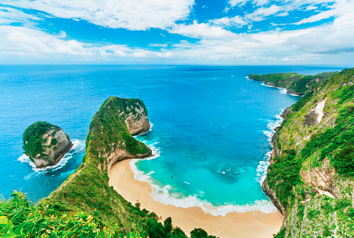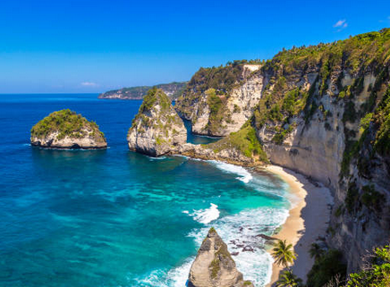

## Day 4 Full day Handara Gate + Ulun Danu (Bedugul) + Tanah Lot Sunset tour + Twin Lake

## Ulundanu Temple Tour of Bedugul tour with Private transfers - ETD 1000 hrs - ETA 1400 hrs : The name of Ulun Danu Beratan Temple is taken from the lake where the temple is built at Beratan Lake. The name of Beratan Lake is inseparable with the Beratan Mount as Deity and Goddess as fertility source, prosperity to keep the prosperity in life and society life. In papyrus chronicle of the Mengwi, this temple is referred as the name of Parhyan ganriping giring danu Beratan (sanctum located in lakeside of Beratan Lake). Ulun is come from Hulu word meaning head or power and in this case is intended by Ulun Danu Beratan means power of Beratan Lake that is Danu Goddess with Private transfers

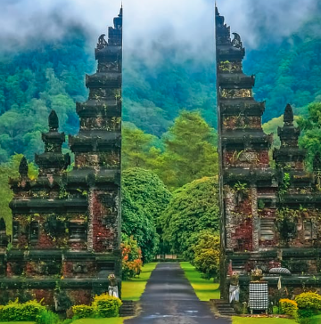 

## Day 05 Bali Swing ACTIVE Package (Swings with local Lunch)+Pirate Dinner Cruise By Sea Safari

## A swing hanging between coconut trees, high atop a hill. Swing and Rafting Both thrilling and addictive, the swing ride of your life is almost guaranteed – at such a height, and with sweeping views of the jungle Capture the spectacular Bali sunset from an ideal vantage point on a 4-hour dinner cruise. Perfect for couples, families, and friend groups alike, the evening tour is the perfect way to complete your day in Bali. After boarding the ship, kick off your evening with a welcome cocktail and canapés on the open-air deck. Then tuck in to an open buffet dinner, which includes a wide variety of international options

## Day 6 ****Bali to Gili Trawangan Transfers (Including Fast Boat)****

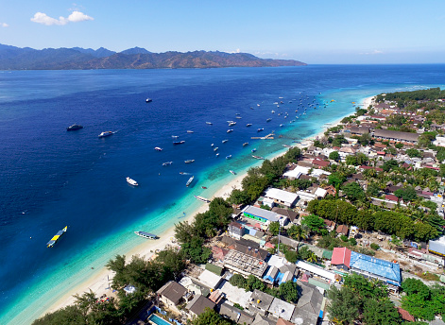

## Day 7 ****Gili Trawangan to Bali Transfers (Including Fast Boat)**** ****Tirta Gangga****

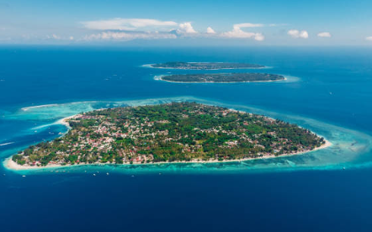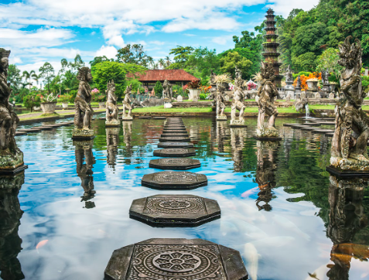

**Day 08 Kintamani + Coffee Plantation + Ubud Market & Palace + Tegalalang Rice Terrace + Sacred Monkey Forest, Ubud**

Pick up @ 0800 hrs. Full day tour includes visit to Kintamani area for (view only) Mount and Lake Batur from Viewing point + Coffee Plantation (If time permits) + Tegenungan Water fall + Tegalalang Ubud monkey forest

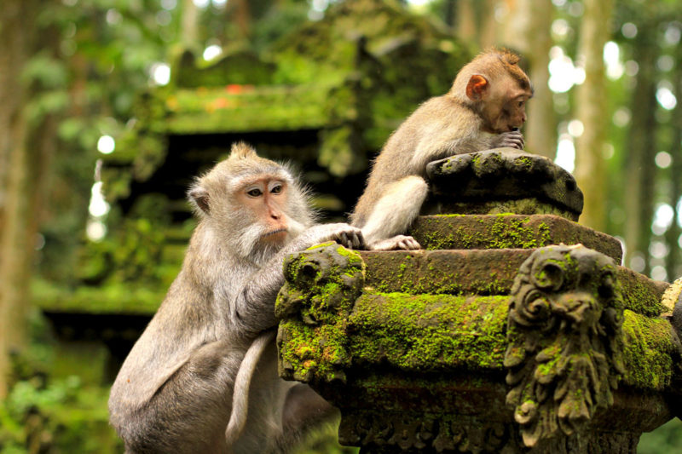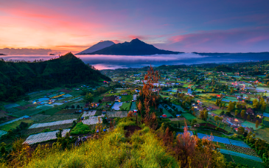

**Day 9 Half Day Uluwatu Sunset tour + Kecak & Fire Dance Show**

Uluwatu temple with Private transfers - ETD 1600 hrs - ETA 1900 hrs - The beautiful Uluwatu temple, built on the top of a cliff about 825 feet high facing the vast deep blue Indian Ocean, and catch a wonderful view of sunset. Kecak dance performance: - Post sunset witness the Kecak and Fire Dance - Completely dramatic. Originally from Ramayana this show depicts the famous ‘Lanka Dahan’ episode wherein Hanuman sets fire to the kingdom of Ravana. The enthralling ‘kecak, kecak’ chant is the USP

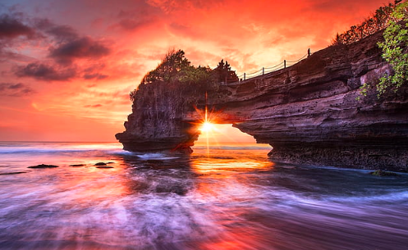 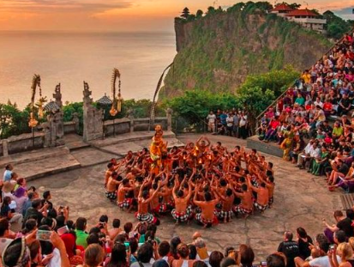

**Day 10 Departure from Bali**

Morning breakfast at hotel, after having breakfast hotel and picked up from Hotel's lobby at the time confirmed. Please be available at the lobby 15 minutes before the time given and you will be transferred to the airport for your flight.



**Inclusions:**

1. Meet & Greet at Airport.

# 09 Nights’ Accommodation in above mentioned hotel.

# Daily breakfast at hotel.

# Return Airport & Inter Hotel transfer on Pvt Basis.

# Full Day Nusa Penida West tour (PRIVATE) - 4 beaches - Kelingking Beach, Angel Bilabong, Broken Bay, Crystal bay + Complimentary Snorkelling (If time permits)

# Water Sports (Banana Boat, Adventure / Couple Parasailing, Jet Ski + Glass Bottom Boat + Turtle Island) + Padang Padang beach + Dreamland Beach

# FD Handara Gate + Ulun Danu (Bedugul) + Tanah Lot Sunset tour + Twin Lake

# Bali Swing ACTIVE Package (Swings with local Lunch) + Pirate Dinner Cruise By Sea Safari

# Bali to Gili Trawangan Transfers (Including Fast Boat)

# Gili Trawangan to Bali Transfers (Including Fast Boat)**TirtaGangga**

# Full Day Tour Visit Kintamani Volcano with Tegallalang Rice Terraces Followed by Ubud monkey forest

# Half Day Uluwatu Sunset tour + Kecak & Fire Dance Show

# English speaking driver cum guide assistance

# TCS

# GST

**Exclusions:**

1. Travel Insurance
2. Tips and porter chargers.
3. Early check in and late checkout at the hotel.
4. Expenses of personal nature.
5. Any other services not specified above.
6. Additional Costs due to Flight Cancellations ,Road blocks ,natural calamities and nature's
7. Any expenses of personal nature such as Porterage, laundry, and alcohol, food or drink not in the regular menus provided by mini bar, telephone calls and us.
8. Any extra meals not included in the itinerary. Meals are pre-set and a choice of menu is not available.
9. Anything that is not specified in the Itinerary.
10. Any extra cost incurred on behalf of an individual due to illness, accident, hospitalization, or any personal emergency.
11. Early check-in and late checkout are on request basis only and subject to room availability [Standard International Check – in time is 1500 hrs. and check out time is 1100 hrs. (**Subject to change as per Hotel’s policy)]
12. Surcharges applicable during conventions, special events and trade fairs.
13. Cost of any other services not specifically mentioned in inclusions.
14. Any increase in the cost that may come into force prior to the departure date including change in price owing to fluctuation in the rate of exchange.

**Note:**

* + Standard Hotel Check-in Time 1400 hrs.
  + Standard Hotel Check-out Time 1100 hrs.
  + Airfare is subject to availability. It can fluctuate anytime.
  + We have not blocked or hold any service as of now

**Terms & Conditions:**

1. The above is only a quote and no bookings have been made yet.
2. Surcharges applicable during Conventions, Special Events and Trade fairs.
3. If the Covid Test (PCR) is positive, then as per government quarantine stay might extend as per rules.
4. The above quotation has been based on specific hotels. According to occupancies, hotels are subject to change. In case the hotel rooms are not available as specified above the alternate hotels will be suggested. The difference in cost is payable extra.
5. Booking amount is non - refundable
6. All confirmations are subject to availability at the time of booking.
7. Rates are subject to change without prior notice due to circumstances beyond our control e.g. Rate Fluctuations, Fuel Increases, Government Regulations, Government Levies, Duties, etc.
8. Please do not store money and valuables in your checked in baggage.
9. All Rates are Valid for Indian Passport Holders
10. Due to any Natural Calamities / unavoidable circumstances / Political or Social unrest, if client postpone or cancel the journey in case of any liability from Airline or Hotel client will be charged for the same. Any waiver request or reduction in cancellation amount request will be at airline or hotel discretion.
11. On certain days, due to some unavoidable conditions we may sometimes amend/ reverse the itinerary and keep you informed. However, all the services/ inclusions will remain the same.
12. Tours and transfers depart strictly as per the time mentioned on final itinerary.
13. Mid night surcharge is applicable as per flight details.
14. We strongly advise passengers to take out insurance covering cancellations, medical expenses, and loss of baggage, curtailment and default at the time of booking.
15. No refund will be provided for any unutilized services.

**Payment Policy:**

|  |  |
| --- | --- |
| Days before departure | Package amount to be paid |
| Booking confirmation | 25 % of the land package non refundable |
| 30 days | 100% |
| Hotel | 100% Room cost in case of non- refundable |
| Airfare | 100% flight cost required at the time of booking |

**Cancelation Policy:**

* Date of booking to 30 days before check in the cancellation charges will be 25% of the package cost.
* 30 to 15 days before check in the cancellation charges will be 50% of the package cost.
* 15 to 7 days before check in the cancellation charges will be 75% of the package cost.
* Less than 7 days before check in Total amount will be forfeited and no refund shall be given.
* No show Total amount will be forfeited and no refund shall be given.
* No refunds shall be given in case of any cancellations due to natural calamities.

**Bank Details:**

|  |  |
| --- | --- |
| Bank Name | HDFC BANK |
| Account Type | Current Account |
| Account Name | Tripzygo International |
| Account Number | 50200068661036 |
| IFSC Code | HDFC0005246 |

**May you have an amazing vacation!**

To know more about the unexplored places, follow us on

**Tricity Plaza, Office number 336 - 338 Third floor, Peer Muchalla, Zirakpur, Punjab 140603**